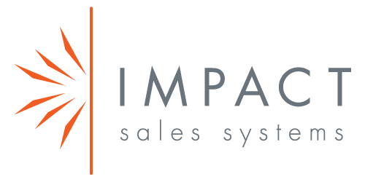 | Amy Rudy  Chief Impact Officer  (812) 987-4244

Amy Rudy Bio

Speaker Biography
Amy and her company, Impact Sales Systems works with business owners and their sales teams on the behaviors behind selling. She resolves the identified issues with sales processes, challenges or issues affecting results and incomes. In fact, she contracts to a result for real, permanent change in sales growth.

Previously, Amy founded a software development firm, ACR Computer Resources in 1994 which offered custom software solutions for a number of regional and national clients. For seven years beginning in 1987, Amy worked with Brown-Forman in the development its merchant services division, Brown-Forman Enterprises.
Amy is active in U of L’s Family Business Center, Facilitates a NextGen Roundtable for the FBC, One Southern Indiana’s Metro Manufacturing Alliance as a roundtable facilitator, is a member of The Community Foundation of Southern Indiana’s Impact 100, recently served on the NAWBO-Kentucky Board of Directors, and speaks at local and national conferences on Revenue Generation and Business Growth.

