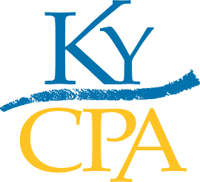

The Kentucky Society of Certified Public Accountants (KyCPA)
NEWS RELEASE

CONTACT:
Kimberly Lindsey
KyCPA Communications Director
502.266.5272 klindsey@kycpa.org

For immediate release

KyCPA mourns the passing and celebrates the life of
Heather Hibbs, membership and operations director
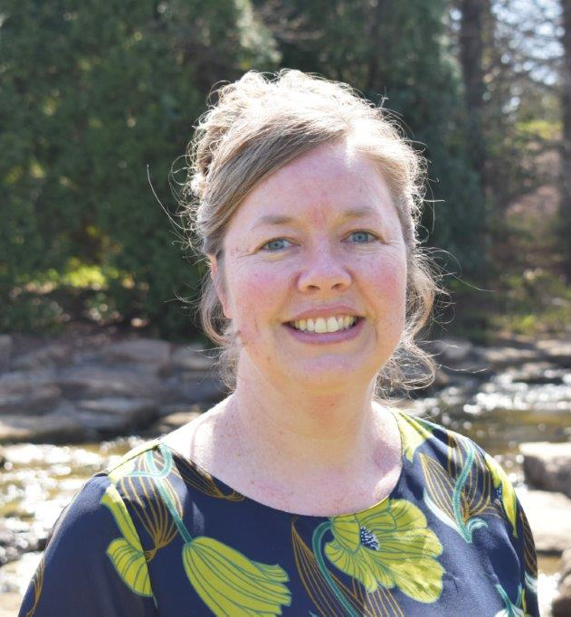
Louisville, Kentucky (January 26, 2022) – With great sadness, the staff and leadership of KyCPA share the news that Heather Hibbs, KyCPA membership and operations director, has lost her battle with cancer and passed away on January 22, 2022. She was 46 years old.

Heather began her career at KyCPA in 1993 as the receptionist and through diligence, hard work, talent and dedication, rose through the staff ranks to a leadership position. She impacted every member, often being the first interaction members experienced with KyCPA. As the receptionist, Heather was the first smiling face for each member who entered KyCPA headquarters and the friendly, reassuring voice that answered when a member called. In 2002, Heather became the marketing and membership coordinator and, in 2006, member services manager. Heather earned her bachelor’s degree in business administration, management and operations in December of 2010 from Indiana Wesleyan University. In 2011, she was promoted to membership director, and in 2017 to membership and operations director.

Heather was at the forefront of helping the Society provide members with benefits, services, resources and meaningful event experiences. She was an integral part of more than 50 awards banquets, celebrating newly licensed Kentucky CPAs and welcoming them into the profession. Heather was professional, kind, took pride in her work and always wore well-coordinated attire to go with her fabulous shoes.

The impact of her work for the CPA profession in Kentucky cannot adequately be measured.

“We are deeply saddened by Heather’s passing. She was an integral part of KyCPA, sharing in many milestones of our members. Her works follow on in our memory of her kindness, dedication, and joy in serving others.” - Eric Scott, KyCPA Board of Directors Chair

Heather was strong in her faith, adored animals (especially her dog, Gizmo), enjoyed spending time with family, cherished trips to the Tennessee mountains and was a gifted pianist. She is survived by her husband, Brian; her mother, Bonnie Wallace; and her brother, Mark Wallace.

"It’s impossible to sum up Heather’s importance and impact on those whose lives she touched. She was the heart of this organization, a good friend to all, and she will be dearly missed."
- Darlene Zibart, KyCPA CEO

_________________________

Click here to donate, in Heather's honor, to the KyCPA Educational Foundation.
Click here for Heather’s obituary and funeral arrangements.
Click here to view a special video tribute to Heather.
_________________________

About KyCPA: The Kentucky Society of Certified Public Accountants (KyCPA) is a statewide, non-profit professional organization serving CPAs in public accounting firms, business, industry, government and education. www.kycpa.org.

***

